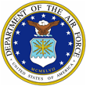 | 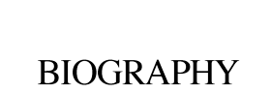 | 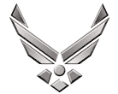

U N I T E D S T A T E S A I R F O R C E

CHIEF MASTER SERGEANT WILLIAM J. KEITER
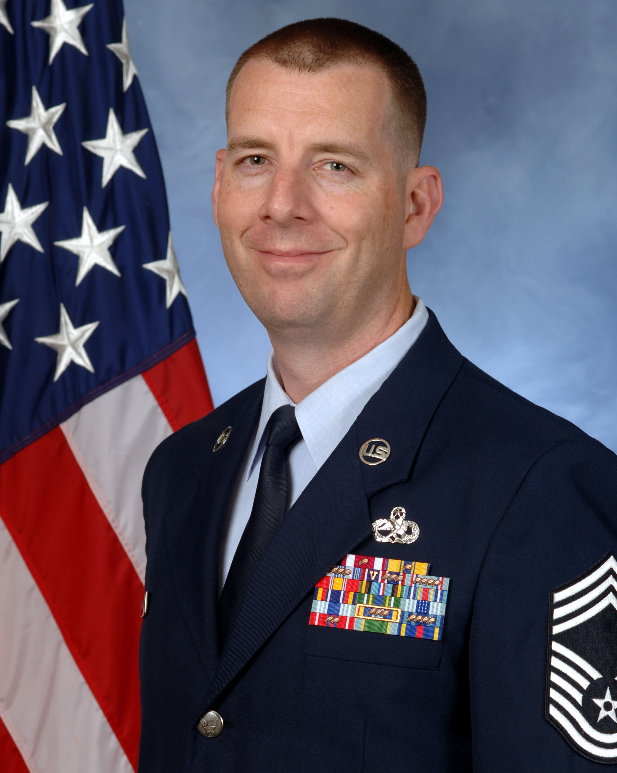
Chief Master Sergeant William J. Keiter is the Superintendent of the F-22 Aircraft Maintenance Unit, 15 Aircraft Maintenance Squadron, Joint Base Pearl Harbor Hickam, Hawaii. In this position, he leads a diverse team of 217 Total Force Airmen in partnership with the Hawaii Air National Guard to provide on-equipment maintenance for 20 of the world’s premiere F-22A fighter aircraft valued at $2.6B. He ensures safe and timely execution of an annual flying hour program consisting of 2,300 sorties and 3,100 flying hours while maintaining a Pacific Air Force Alert mission supporting operations across Hawaii and throughout the Pacific Theater.

Chief Master Sergeant Keiter was born in Dayton, Ohio and graduated from Xenia High School in 1997 and entered the Air Force in June of the same year. He attended technical training at Sheppard Air Force Base, Texas and subsequently reported to Cannon Air Force Base, New Mexico as an F-16C Communications, Navigation, and Penetration Aids Avionics Systems Specialist. His maintenance background encompasses F-16C/D, MQ-1, A-10, and F-22A airframes. His assignments include bases in New Mexico, Republic of South Korea, Nevada, Texas, Alaska, and Hawaii. Additionally, Sergeant Keiter has deployed four times in support of diverse operations throughout Southwest Asia.

EDUCATION
1998 F-16 Communication, Navigation, and Penetration Aids Apprentice course, Sheppard AFB, Texas
2002 Graduate, Airman Leadership School, Nellis AFB, NV
2004 Graduate, Air Force Basic Instructor course
2005 Associate in Applied Science Degree, Avionics System Technology, CCAF
2005 Associates in Instructor of Technology and Military Science, CCAF
2007 Graduate, Gaylor Noncommissioned Officer Academy, Lackland AFB, TX,
2010 Bachelor of Science in Professional Aeronautics, Embry Riddle Aeronautical University
2010 Pacific Air Force Inspector General Basic Inspectors course
2012 Professional Manager Certification, CCAF
2013 Graduate, Air Force Senior Noncommissioned Officer Academy, Maxwell-Gunter AFB, Alabama
2014 Instructional Systems Design (ISD) Certification, CCAF
2015 Senior Enlisted Joint Professional Military Education (SEJPME I)
2017 Chief’s Orientation Course, Hickam AB, Hawaii

ASSIGNMENTS
1. Jun 97 – Aug 97, Trainee, Basic Military Training, Lackland AFB, TX
2. Aug 97 – Oct 97, Student, Electronic Principles course, Lackland AFB, TX
3. Oct 97 – Mar 98, Student, F-16C/D Avionics Systems Apprentice course, Sheppard AFB, TX
4. Mar 98 – Dec 99, F-16 Avionics Apprentice, 522th Fighter Squadron, Cannon AFB, NM
5. Dec 99 – Jan 01, F-16 Avionics Journeyman, 36th Fighter Squadron, Osan AB, Korea
6. Jan 01 – Feb 04, MQ-1 Avionic Journeyman, 15th Reconnaissance Squadron, Indian Springs AFB, NV
7. February 04 – May 09, F-16 Fighter Avionics Instructor, 365th Training Squadron, Sheppard AFB, TX
8. May 09 – Oct 11, Specialist Section Chief, 354th Aircraft Maintenance Unit, Eielson AFB, AK
9. Oct 11 – May 12, Production Superintendent, 354th Aircraft Maintenance Unit, Eielson AFB, AK
10. May 12 – Oct 12, 2A3X5 CDC Writer, 365th Training Squadron, Sheppard AFB, TX
11. Nov 12 – May 13, Fighter Avionics Flight Chief, 365th Training Squadron, Sheppard AFB, TX
12. May 13 – Jul 15, Squadron Superintendent, 365th Training Squadron, Sheppard AFB, TX
13. July 2015 – Mar 16, Assistant Superintendent, 36th Aircraft Maintenance Unit, Osan AB, Korea
14. Apr 16 – Jul 16, Superintendent, 25th Aircraft Maintenance Unit, Osan Ab, Korea
15. Jul 16 – Present, Superintendent, 19th Aircraft Maintenance Unit, Joint Base Pearl Harbor Hickam, Hawaii

MAJOR AWARDS AND DECORATIONS
Air Force Meritorious Service Medal with two oak leaf clusters
Air Force Commendation Medal with one oak leaf cluster
Air Force Achievement Medal with three oak leaf clusters
AF Outstanding Unit Award with Valor Device
Armed Forces Expeditionary Medal
Global War on Terrorism Expeditionary Medal
Global War on Terrorism Service Medal
Korean Defense Service Medal
Air Force Expeditionary Service Ribbon with Gold Border
Small Arms Expert Marksmanship Ribbon

OTHER ACHIEVEMENTS
1998 Top Graduate, F-16 Avionics Technical Training course, Sheppard AFB, TX
2007 Distinguished Graduate, Noncommissioned Officer Academy, Lackland AFB, TX
2008 Master Instructor Certification, Sheppard AFB, TX
2010 Lance P. Sijan Award-SNCO, 354th Maintenance Group, Eielson AFB, AK
2010 Summa Cum Laude, Embry Riddle Aeronautical University
2010 SNCO of the Year, 354th Maintenance Group, Eielson AFB, AK
2011 PACAF Outstanding EW SNCO of the Year
2013 SNCO of the Year, 365th Training Squadron, Sheppard AFB, TX
2014 Support SNCO of the Year, 365th Training Squadron, Sheppard AFB, TX
2015 SNCO of the Year, 51st Aircraft Maintenance Squadron, Osan AB, Korea
2016 Lance P. Sijan Award-SNCO, 51st Maintenance Group, Osan AB, Korea

EFFECTIVE DATE OF PROMOTION
Chief Master Sergeant August 2017
(Current as of Jan 2018)

